

SCHOOL OF INFORMATICS & IT

Part 2: Microservices Implementation

Student Name (Matric Number) : MAY THET NAING BO (2303675I)

Tutorial Group : TC07
Jenny LING (TP)
Tutor : Mr. Ryan Chia

Submission Date : 24/06/2024

Declaration of Originality

I am the originator of this work and I have appropriately acknowledged all other original sources used as my references for this work.

I understand that Plagiarism is the act of taking and using the whole or any part of another person’s work, including work generated by AI, and presenting it as my own.

I understand that Plagiarism is an academic offence
and if I am found to have committed or abetted the offence of plagiarism in relation to this submitted work, disciplinary action will be enforced.

Declaration on the use of Generative AI tools for assignments

Describe how you have used Generative AI tools such as ChatGPT or Dall.E-2 in your assignment.

Show snapshots of the conversations with the AI tool (i.e., the prompts you used and the response you get from the AI tool).

How do you indicate the reference?
The content generated by AI tools are not retrievable except by the user who generated them, so they are considered non-recoverable sources. Although non-recoverable data or quotations in APA Style papers are usually cited as personal communications, with ChatGPT-generated text there is no person communicating. Quoting text from ChatGPT chat is therefore more like sharing the output of an algorithm, with a reference list entry and the corresponding in-text citation.

According to the official APA Style site, ChatGPT references should be cited as:

E.g. OpenAI. (2023). ChatGPT (Sep 25 version) [Large language model].
https://chat.openai.com/chat

Important Note:

- Do not copy answers produced by the AI tool in totality as it is considered as plagiarism.

- Do not rely on any information produced by the AI tool blindly. You should always verify the answer with other sources. Do not assume that these answers provided by the AI tool are correct.

To achieve quality outputs from the AI tool, you should provide good prompt that is clear and specific. Be precise and provide context. Avoid asking open-ended questions.
Temasek Polytechnic School of Informatics & IT
Diploma in Information Technology
Cloud Application Development (CIT2C24)
Microservices Implementation

Practical Class: | P07
Submitted by:  (list all students) | <May Thet Naing Bo> / <2303675I>
Date: | 24 / 06 / 2024

API Documentation
Copy and paste the API documentation from Part 1 Proposal and amend if necessary. Include the payload for requests, if any. The HTTP message payload refers to the body data that is sent in the HTTP request.

RDS

Service Name | HTTP method | Relative URI | Action | Payload
User Management Service | GET | /api/user | Get all users | Nil
User Management Service | POST | /api/user | Register new user | {  "user_id": 7,  "user_name": "Crystal",  "password": "mtnb2511"  }
User Management Service | POST | /api/login | Login the existing user | {  "user_name": "Crystal",  "password": "mtnb2511"  }
User Management Service | PUT | /api/user/{id} | Update user by ID | {  "user_name": "Crystal Jane",  "password": "mtnb2511"  }
User Management Service | GET | /api/user/{id} | Get user id and group id | Nil
User Management Service | GET | /api/user_group | Get group by user id | Nil
User Management Service | GET | /api/gp_by_user | Get user by ID | Nil
User Management Service | DELETE | /api/user/{id} | Delete user by ID | Nil
Group Management Service | GET | /api/group | Get all groups | Nil
Group Management Service | GET | /api/group/{id} | Get group by ID | Nil
Group Management Service | GET | /api/grouptask | Get all group tasks | Nil
Group Management Service | GET | /api/grouptask/{id} | Get group tasks by ID | Nil
Group Management Service | POST | /api/grouptask | Add a new group task | {  "grouptask_id": 1004,  "gptask_description": "Consists of May, Crystal and Jane",  "gptask_deadline": "2024-11-28",  "gptask_status": "In Progress",  }
Group Management Service | POST | /api/group | Add a new group | {  "group_id": 4,  "grouptask_id": 1004,  "group_description": "IIT TC07 CDAV",  }
Group Management Service | PUT | /api/grouptask/{id} | Update group task by ID | {  "grouptask_id": 1004,  "gptask_description": "Updated group Task Information",  "gptask_deadline": "2024-11-28",  "gptask_status": "In Progress",  }
Group Management Service | PUT | /api/group/{id} | Update group by ID | {  "group_id": 4,  "grouptask_id": 1004,  "group_description": "IIT TC07 CDAV Part 2",  }
Group Management Service | DELETE | /api/group/{id} | Delete group | Nil

Dynamo DB
Service Name | HTTP method | Relative URI | Action | Payload
User Management service | PUT | /api/user-profile | Update the user profile | {  "user_name": "Crystal",  "password": "NewPassword128"  }
User Management service | POST | /api/user-register | Register new user | {  "user_name": "test_user",  "password": "TestPassword123"  }
User Management service | POST | /api/user-login | Login the user | {  "user_name": "test_user",  "password": "TestPassword123"  }
Task Management Service | PUT | /api/update-task | Update a task | {  "task_id": 10007,  "user_id": 10001,  "task_deadline": "2023-12-31",  "task_description": "Updated task description",  "task_status": "Completed",  "task_title": "Updated task title"  }
Task Management Service | DELETE | /api/task/{task_id}/{user_id} | Delete task by task id and user id | Nil
Task Management Service | POST | /api/add-task | Add task | {  "task_id": task123,  "user_id": user456,  "task_title": "Completed Project Report",  "task_description": "Complete the final report for the project by the end of the week.",  "task_status": "in-progress",  "task_deadline": "2024-06-30"  }
Task Management Service | DELETE | /api/grouptask/{id} | Delete group task by ID | Nil

Others
- Reasons why I choose to deviate from proposed Microservices Architecture from Proposal

Since I want to test both in RDS method and dynamo DB method, I divided the management services.

RDS – User Management Service & Group Management Service
Dynamo DB – User Management Service & Task Management Service

As I don’t want to mix the data from RDS and dynamo DB, I added one more table which is “user_group” in my SQL.
This table will hold the values of user_id and group_id and perform inner join tables function.
Therefore, the data from user table, group table, user_group table and group_tasks table will be stored with RDS method and another user table and individual_tasks table will be stored in the dynamo DB method.

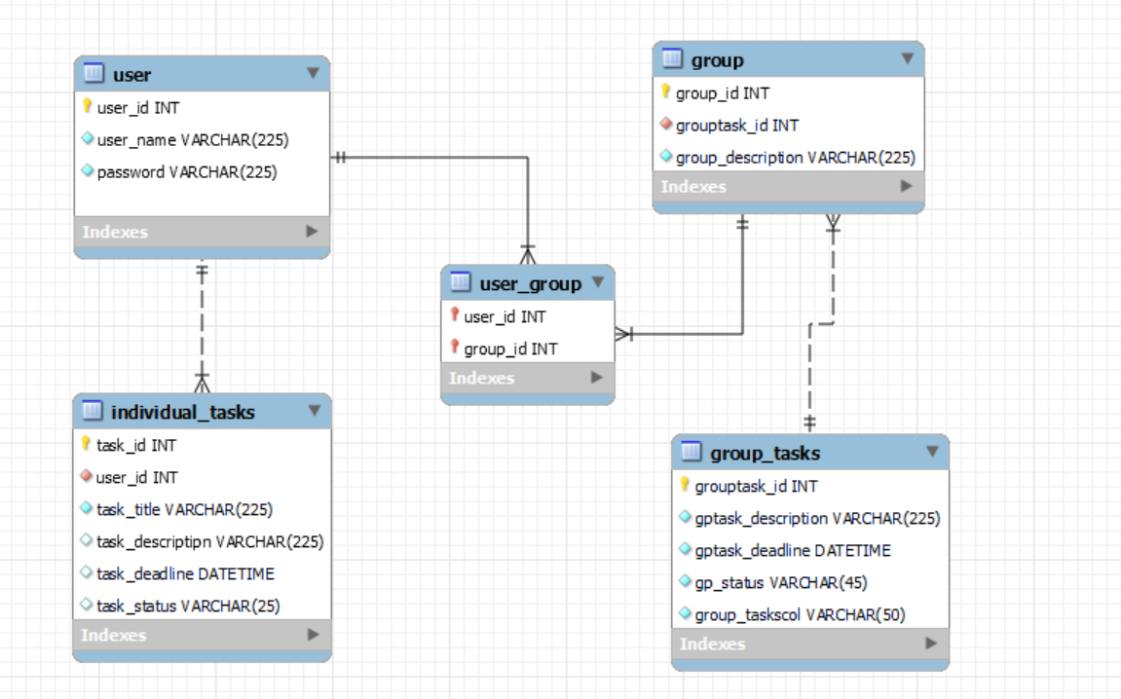

Diagram of Part 2 ER Diagram which slightly deviates from Part 1 ER Diagram

